Aaron Burkhead, Tului Gantulga

Professor Mohamed M. Hafez

EME 199 Special Studies

March 28, 2017

**Introduction**

The purpose of this Special Study is to analyze a structure and its reactions under different kinds of loadings, such as purely its own weight, distributed loading, buckling, and torsion. Linear cases are considered for all loadings and nonlinear cases are considered only for the cases where its own weight and distributed loading cause deflection. The main method used in this study is the Finite Difference Method (FDM). As the number sections increases, the result gets closer to the true deflection for both linear and nonlinear cases, and iterative methods are used for nonlinear cases. The type of nonlinear iterative process used is called “Relaxation Method.” Due to the nature of the differential equations and its extension to matrices, the resulting matrices are in the form of a tridiagonal matrix. Thus, Thomas’ Algorithm is used to solve the matrices. To make sure we get the exact solution, at least close to the exact solution, we choose the simplest case for all cases and solve the equation analytically and compare the analytical solution to the discrete solution. To further simplify the equation, material properties and geometry are taken as constants.

**Buckling**

Buckling happens when a load P is applied at both ends, and the column deflects as a result. Although buckling and bending deflect similarly, their equations and the math behind them are much different from each other. The linear equation for bending is as follows,

$$\frac{d^{2}u}{dx^{2}}-\frac{M\left(x\right)}{EI}=0$$

where u is the deflection, M is bending moment, E is Young’s Modulus, and I is the second moment of area. The linear equation for buckling is,

$$\frac{d^{2}u}{dx^{2}}-\frac{Pu}{EI}=0$$

where P is the load applied at each end of the column. The analytical solution for buckling is,

$$u\left(x\right)=Asin\left(\sqrt{λ}x\right)+Bcos(\sqrt{λ}x)$$

where $λ=\frac{P}{EI}$. Furthermore, with boundary conditions, $u\left(0\right)=0$ and $u\left(L\right)=0$, the following result is yielded,

$$u(x)=Asin\left(\sqrt{λ}x\right)$$

From this and the boundary conditions, $λ=n^{2}π^{2}$ for $n=0,1,2,3,4…$, n describes how the column behaves, for the purposes of this project, n = 1. Following figures show how beams behave during buckling

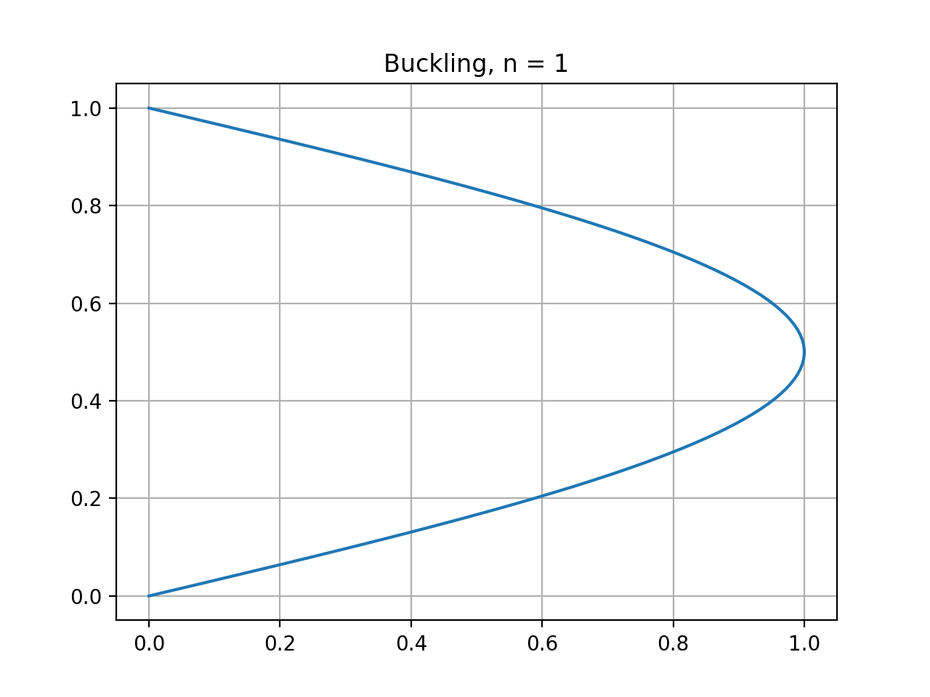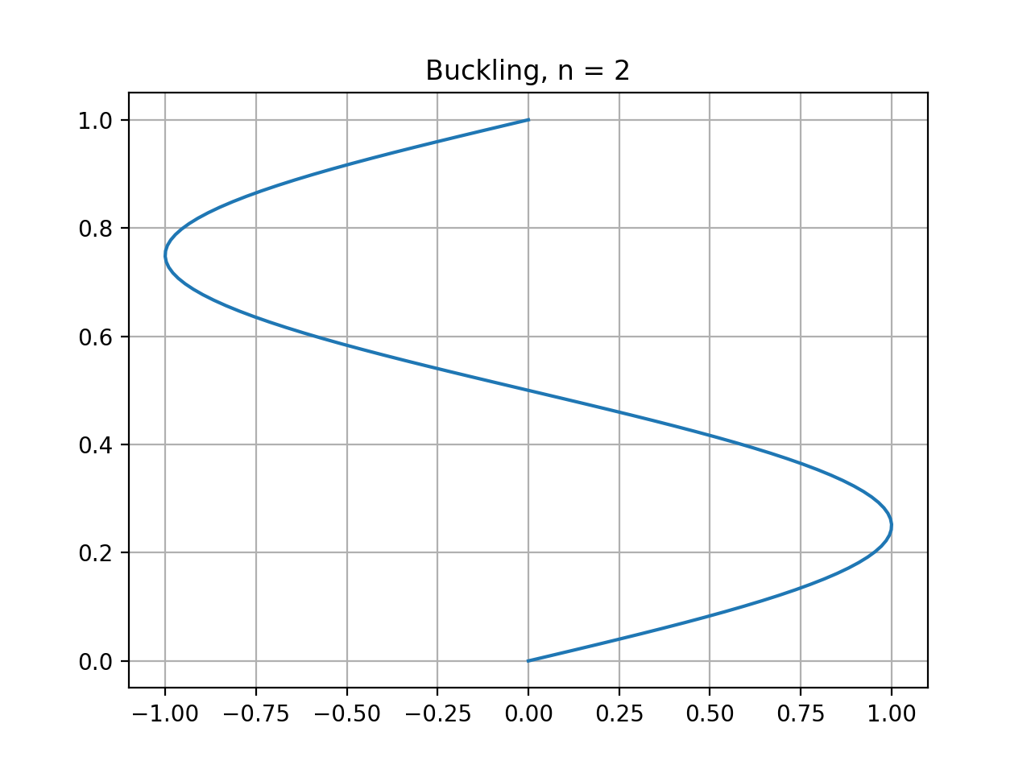

How a beam buckles depends on its material property and its memory. It is more likely to buckle in the same way that it did before. The discretization of the buckling equation is as follows,

$$\frac{u_{i-1}-2u_{i}+u_{i+1}}{Δx^{2}}-λu_{i}=0$$

Combining the terms yields,

$$u_{i-1}-(2+λΔx^{2})u_{i}+u_{i+1}=0$$

Discretized equation in matrix form looks as the following,

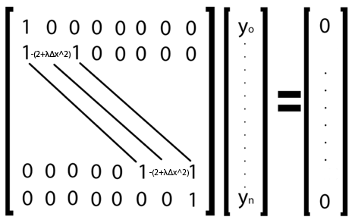

The eigenvalue, $λ$, can be solved through manual calculations for an mxm matrix. The following table shows the relationship between the matrix size m and the eigenvalue $λ$. The value that $λ$ is approaching is $π^{2}=$ 9.8696.

|  |  |
| --- | --- |
| Matrix Size m | Eigenvalue λ |
| 3 | 8 |
| 4 | 9 |
| 5 | 9.37 |
| 6 | 9.549 |
| 7 | 9.646 |
| 8 | 9.705 |

Another way of finding eigenvalue is the Power Method and the Inverse Power Method. These two methods are iterative methods to find an eigenvalue and the eigenvector associated with the eigenvalue. The Power Method gives the biggest eigenvalue and the Inverse Power Method gives the smallest eigenvalue. The Inverse Power Method is of use for this research because the smallest eigenvalue is the what is chosen. The formula for the Power Method is derived as follows,

$$A\vec{u}=λ\vec{u}$$

dot both sides by $\vec{u}$ and divide by $\vec{u}∙\vec{u}$,

$$λ=\frac{\vec{u}∙A\vec{u}}{\vec{u}∙\vec{u}}$$

and the vector iteration is the following because it needs to be normalized,

$$\vec{u}=\frac{\vec{u}}{\left\|\vec{u}\right\|}$$

and the initial guess can be anything but it can affect the convergence rate. For a 500x500 matrix, the initial guess is $u_{0}=[0, 1, 2….m-1,m]$, the convergence of the maximum eigenvalue is as follows,

|  |  |
| --- | --- |
| Iteration | Eigenvalue |
| 1 | 124002748.001 |
| 3 | 721673.460 |
| 5 | 838262.276 |
| 10 | 919335.800 |
| 100 | 988515.201 |
| 1000 | 995256.810 |

The smallest eigenvalue is not 1 divided by the biggest eigenvalue. The Inverse Power Method is used to find the smallest eigenvalue and the only thing that changes is the initial equation,

$$A^{-1}\vec{u}=λ^{-1}\vec{u}$$

dot both sides by $\vec{u}$ and divide by $\vec{u}∙\vec{u}$,

$$\frac{1}{λ}=\frac{\vec{u}∙A^{-1}\vec{u}}{\vec{u}∙\vec{u}}$$

and the vector iteration is the following because it needs to be normalized,

$$\vec{u}=\frac{\vec{u}}{\left\|\vec{u}\right\|}$$

and the initial guess can be anything but it can affect the convergence rate. For a 500x500 matrix, the initial guess is $u_{0}=[0, 1, 2….m-1,m]$, the convergence of the maximum eigenvalue is as follows,

|  |  |
| --- | --- |
| Iteration | Eigenvalue |
| 1 | 14.977 |
| 3 | 9.877 |
| 5 | 9.8696 |
| 10 | 9.8695 |
| 100 | 9.8695 |
| 1000 | 9.8695 |

This shows that both the Power and the Inverse Power Methods are powerful, especially the Inverse Power method because it only takes 5 iterations to get the answer accurate with 4 decimal places. The Power Method is powerful for smaller matrices, but as the size of the matrix increases, so does the biggest eigenvalue, thus, it is harder to get it. Another thing that affects the process is the initial guess, if a better initial guess is chosen, then the results would be much more accurate. During each iteration, the formula is normalizing a vector; this vector is known as the eigenvector. The following graph is the result of a matrix that is 500x500 and repetition of 1000 times.

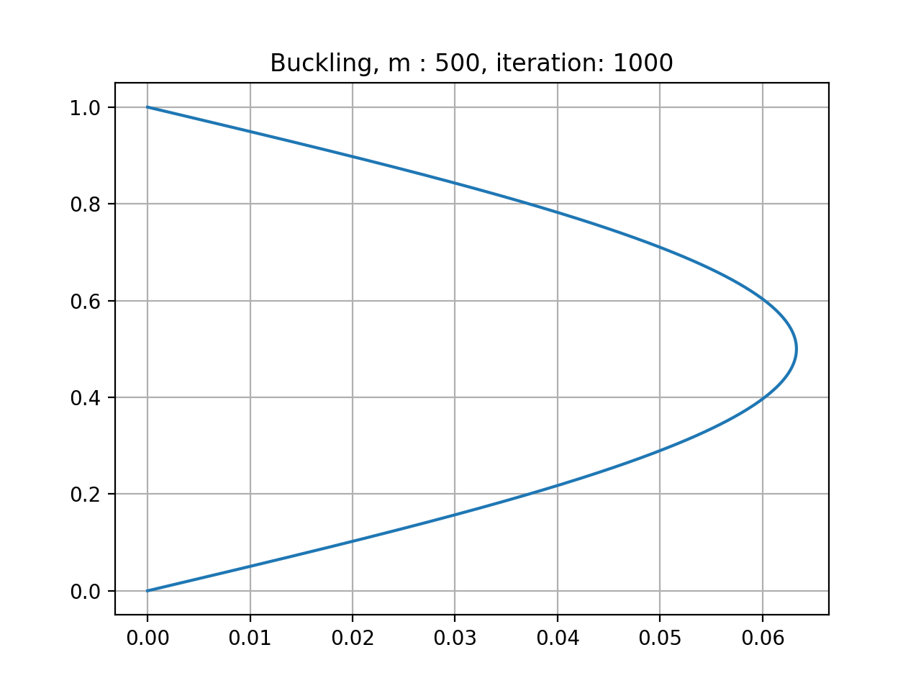

The eigenvector is normalized every iteration, which is why the biggest value is a little over 0.06.